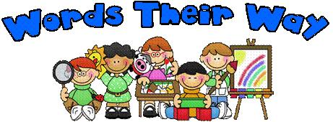

Dear 3T Families,
“Words Their Way” is a word study program that individualizes the way students learn to spell words. Instead of memorizing a list of words for a test, “Words Their Way” has students sort words into different categories. This sorting process helps students analyze and examine patterns in words. After an initial assessment, students are given word sorts at their specific spelling stage allowing us to maximize their spelling growth.
Your child will be bringing home a word sort every 1 to 2 weeks to practice at home. Please aim to have your child practice the sorts about 3-4 times per week, in the manner described below. The sorts will be modelled and practiced in school, so the home practice should be review and should only add a few minutes to your home reading routine. Please practice the sorts in a fun, game-like manner.
Please contact me if you have any questions regarding the “Words Their Way” program. I appreciate your help in supporting your child’s spelling progress.
Sincerely,
Ms. Talwar
Words Their Way Homework

Day 1: - Have your child cut out the words in the sort. These can be stored in an envelope or baggy to use throughout the week. They do not need to be brought back to school as we will use a separate set here.
- Your child should find the headers (the underlined boxes) to place at the top and sort the matching words underneath. Make sure they read the words aloud as they sort them. Have them describe to you why they are putting the words in each group. Afterwards, they should read through each column to check their sorting and fix any mistakes.

Subsequent Days: Choose one activity from the list on the back of this sheet:

- Speed Sort 2) Blind Sort 3) Open Sort 4) Concentration
5) Word Hunt 6) Writing Sort 7) No Peeking Writing Sort

- Speed Sort: Students sort the words as fast as they can, timing themselves if possible. Then they sort again, trying to beat the first time.

- Blind Sort: Parent reads the word to their child without showing it to them. Students must state which category the word belongs in without looking at the word. For fun, try reversing the parent/child roles on a second try.

- Open Sort: Students sort the words into groups without the headers to guide them. They can sort by any category they notice, trying to sort in a new way. (For example, if the original sorting rule was beginning letter sounds, students may now decide to put all the animals into a group, or sort by ending letter sounds etc.)

- Concentration: Lay words face down. Cards are flipped over two at a time. The student/parent is to read the words and determine if they belong in the same category. If the words belong in the same category, the student/parent has found a match and keeps the words. Continue taking turns until all words have been used.

- Word Hunt: When reading home reading books, hunt for words that belong to the categories of the sort (e.g. all the words starting with “sh”). Students can write a list of the words they find on a scrap piece of paper.

- Writing Sort: After sorting the words under the headers, students write down the words in each category.

- No Peeking Writing Sort: Have your child write the header words on a piece of paper. As the parent reads them each word, the child must write the word in the correct category without looking. They score one point for the correct category and one point for the correct spelling.

