### **Keenooshayo Elementary**

780-459-3114

October 30, 2017

[Tara.Talwar@spschools.org](mailto:Tara.Talwar@spschools.org)

[mstalwar.weebly.com](http://mstalwar.weebly.com)

October 2, 2017

banner with apples and crayons

**3T News**

**Bulletin**

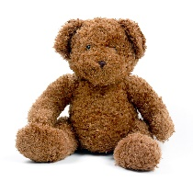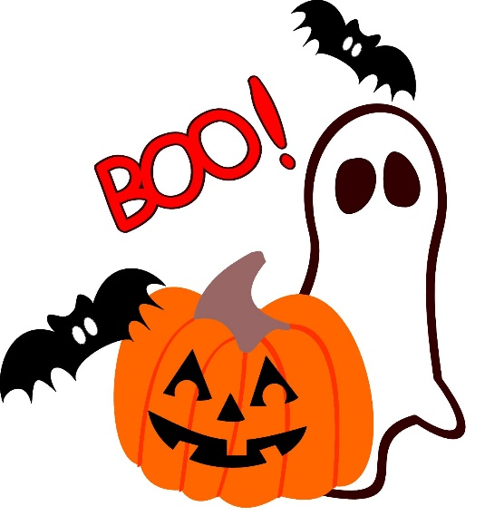

**Math Test – Numbers to 1000**

We will have our first major math test of the year this **Thursday, November 2**. I know this is a busy week with Halloween on Tuesday, but I am hoping that the children will be able to rest up on the half day on Wednesday to be ready to go on Thursday. With report cards just around the corner, the test has to be done this week. However, I am not going to put the newer concepts we have just covered on the test, only those that we have practiced quite a bit over the past weeks. You can go to my website to find links to practice questions that are similar to those on the test if you wish to review with your child at home:

[**mstalwar.weebly.com**](http://mstalwar.weebly.com)

Here is what will be covered on the test:

* Representing 3 digit numbers with numerals, words, and pictures of base ten blocks.
* Explaining what each digit in a 3 digit number means
* Putting 3-digit numbers in order from least to greatest and greatest to least
* Putting 3-digit numbers on a number line
* Counting coins and recording the counting pattern
* Counting forwards and backwards by 5s, 10s, and 100s starting at any number between 0 and 1000

One child left their math home practice booklet on the floor of our classroom. If you did not receive your copy please let me know!

**This Week**

**Tuesday, Oct. 31**:

- Halloween Parade/Party in the afternoon. **Please don’t come dressed in your costumes in the morning.** Bring costumes to change into at lunch. Don’t forget your snacks if you signed up. Thanks!!!

**Wednesday, Nov. 1**:

- Early Dismissal at 12:30 p.m.

- **Dress Like Your Favourite Animal Day**

**Thursday, Nov. 2**

- **Bring a Small Stuffie for Mindfulness**

- Math Unit Test

**Coming Up**

**Friday, November 10**

– Remembrance Day Assembly

**Monday, November 13 – No School**

**Tuesday, November 14 – No School**